The post grey installation and simple table creation were discussed and simple creation is shown

Task were given to prepare a school database management system

And add 100 rows and insert query delete query and update query

The E-R diagram for this is attached as another doc

So first table student is created and added 100 rows

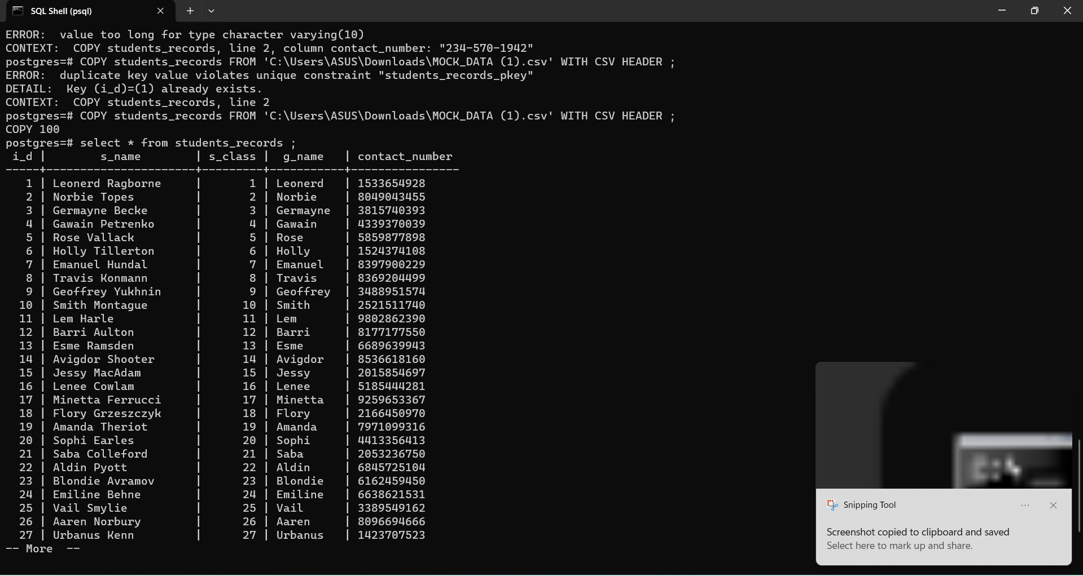

Inserting data

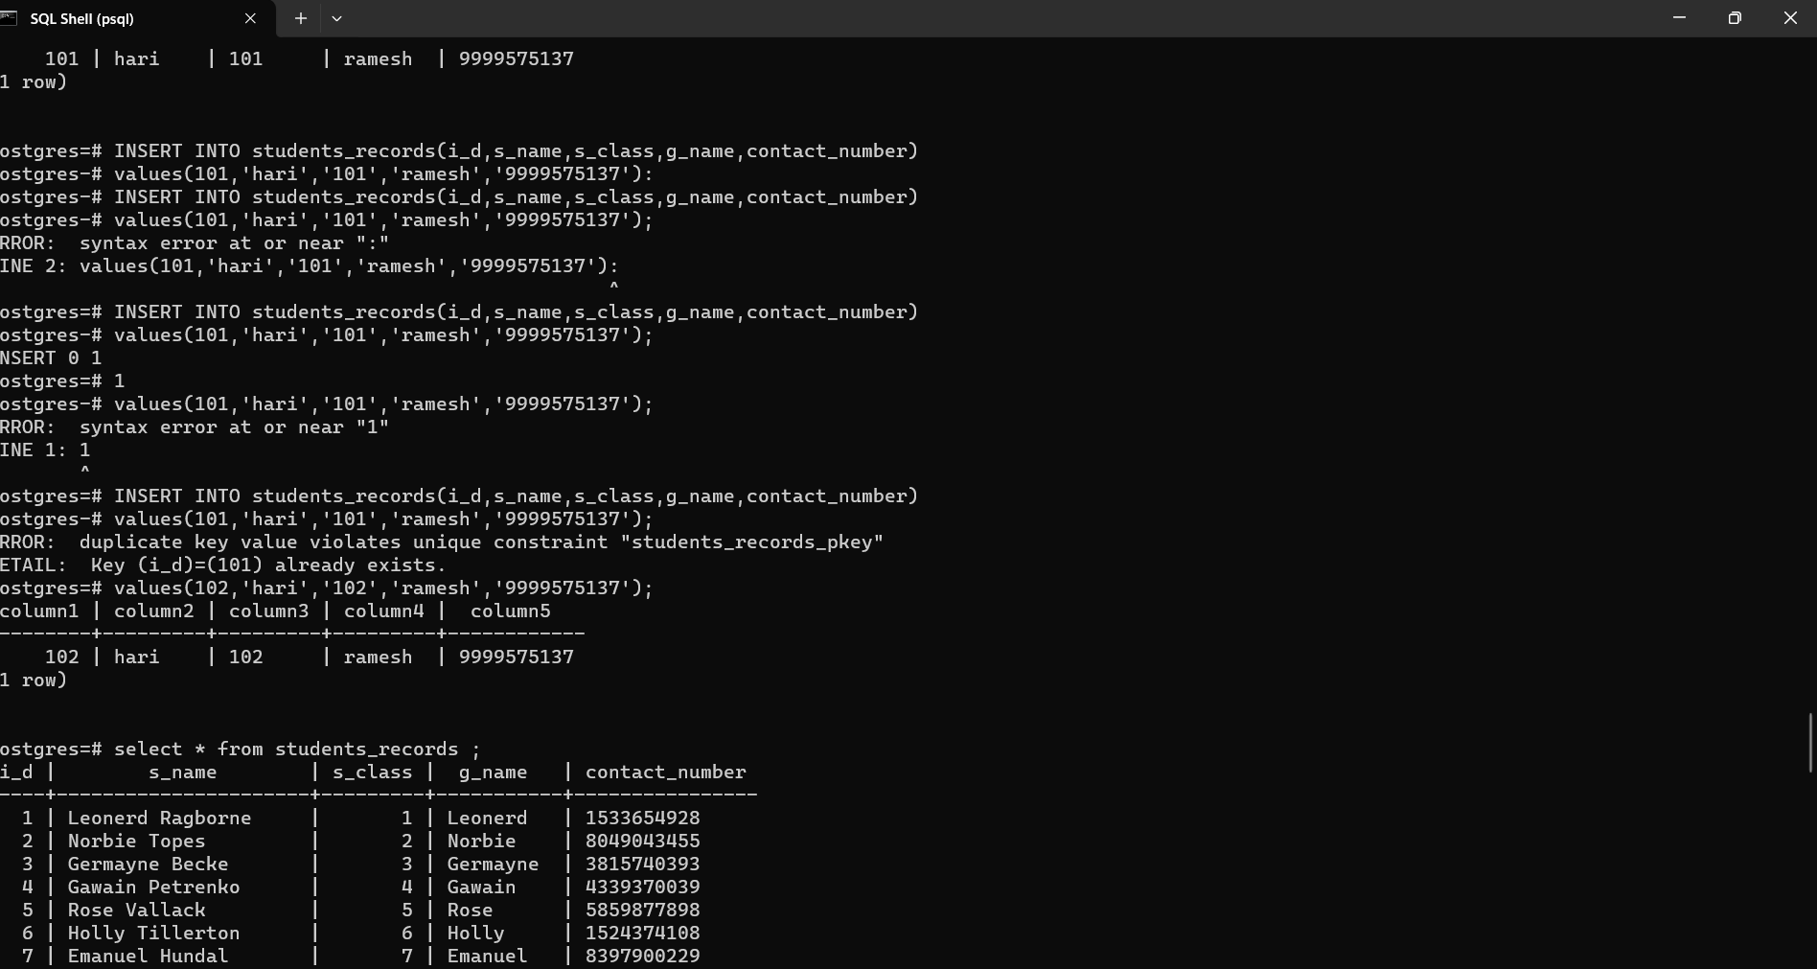

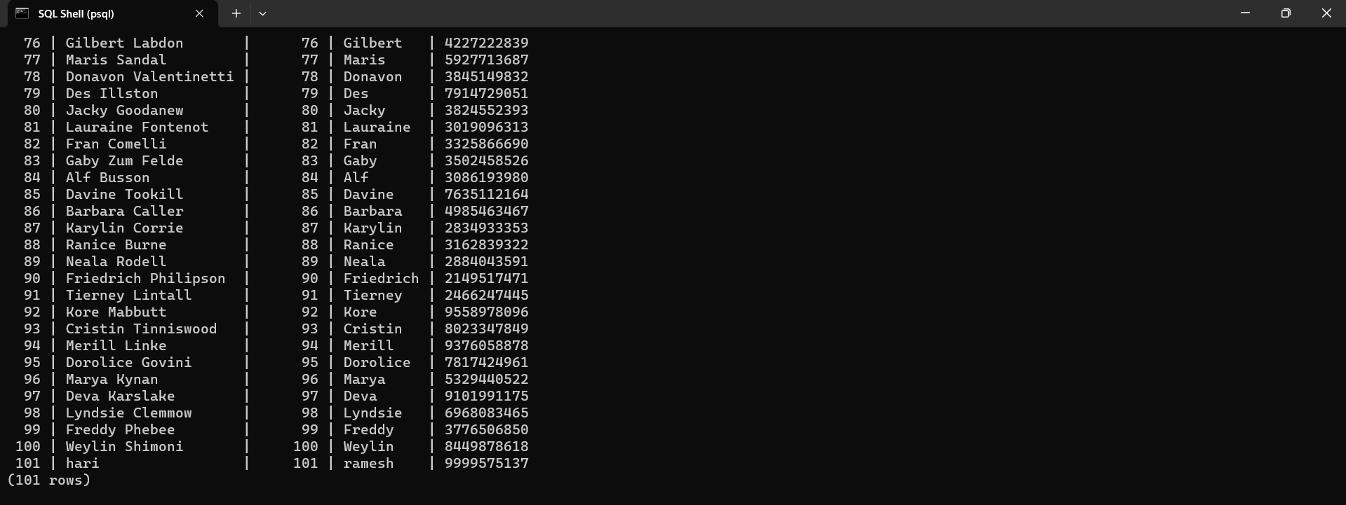

Deleting a query

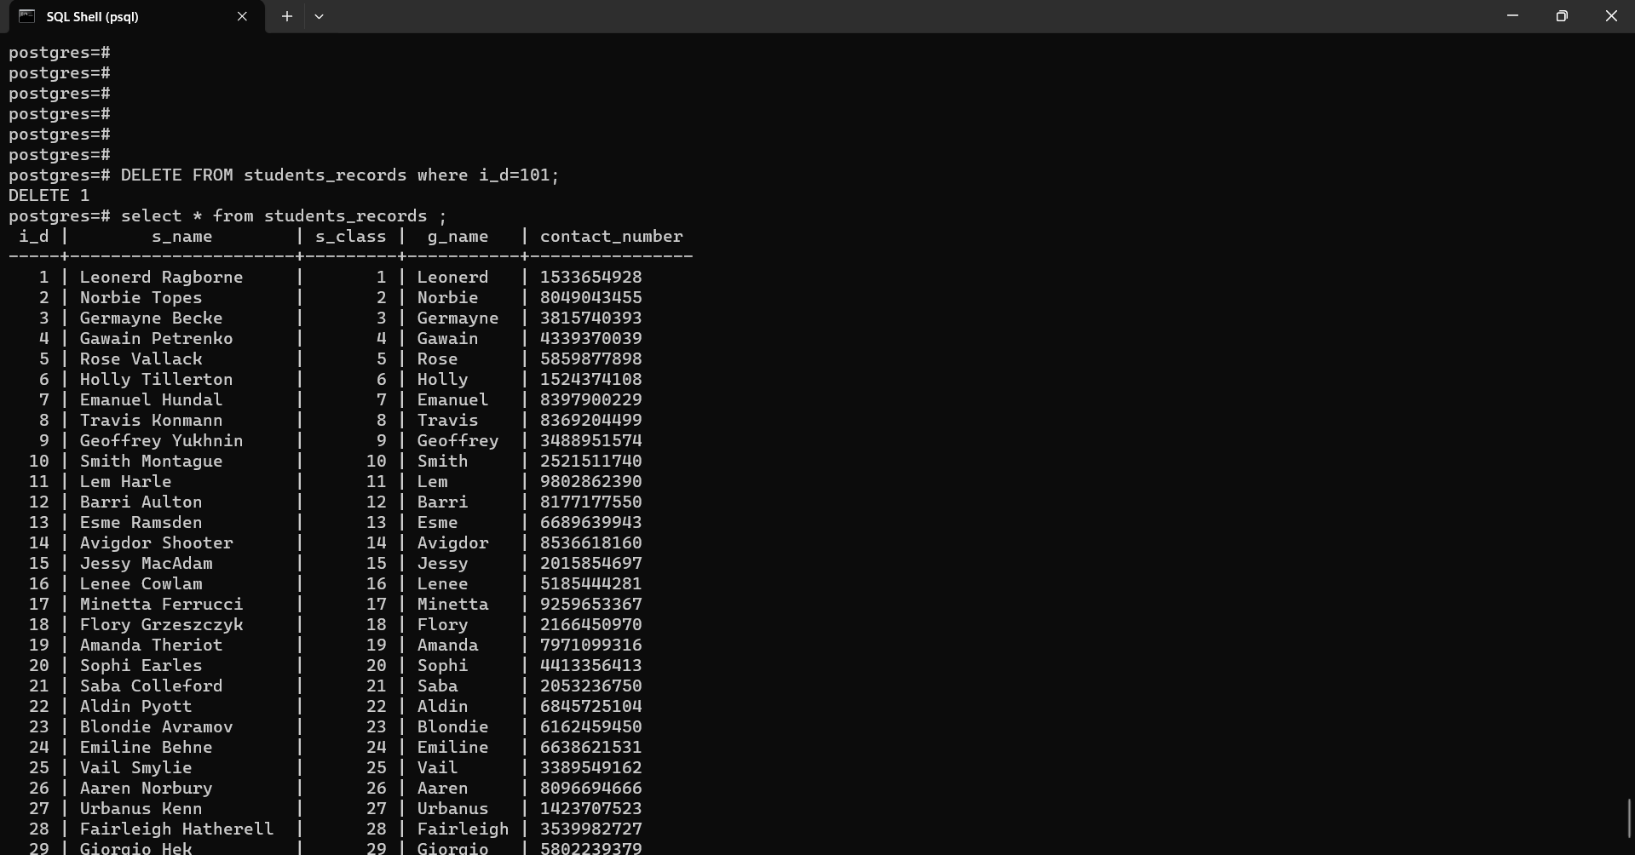

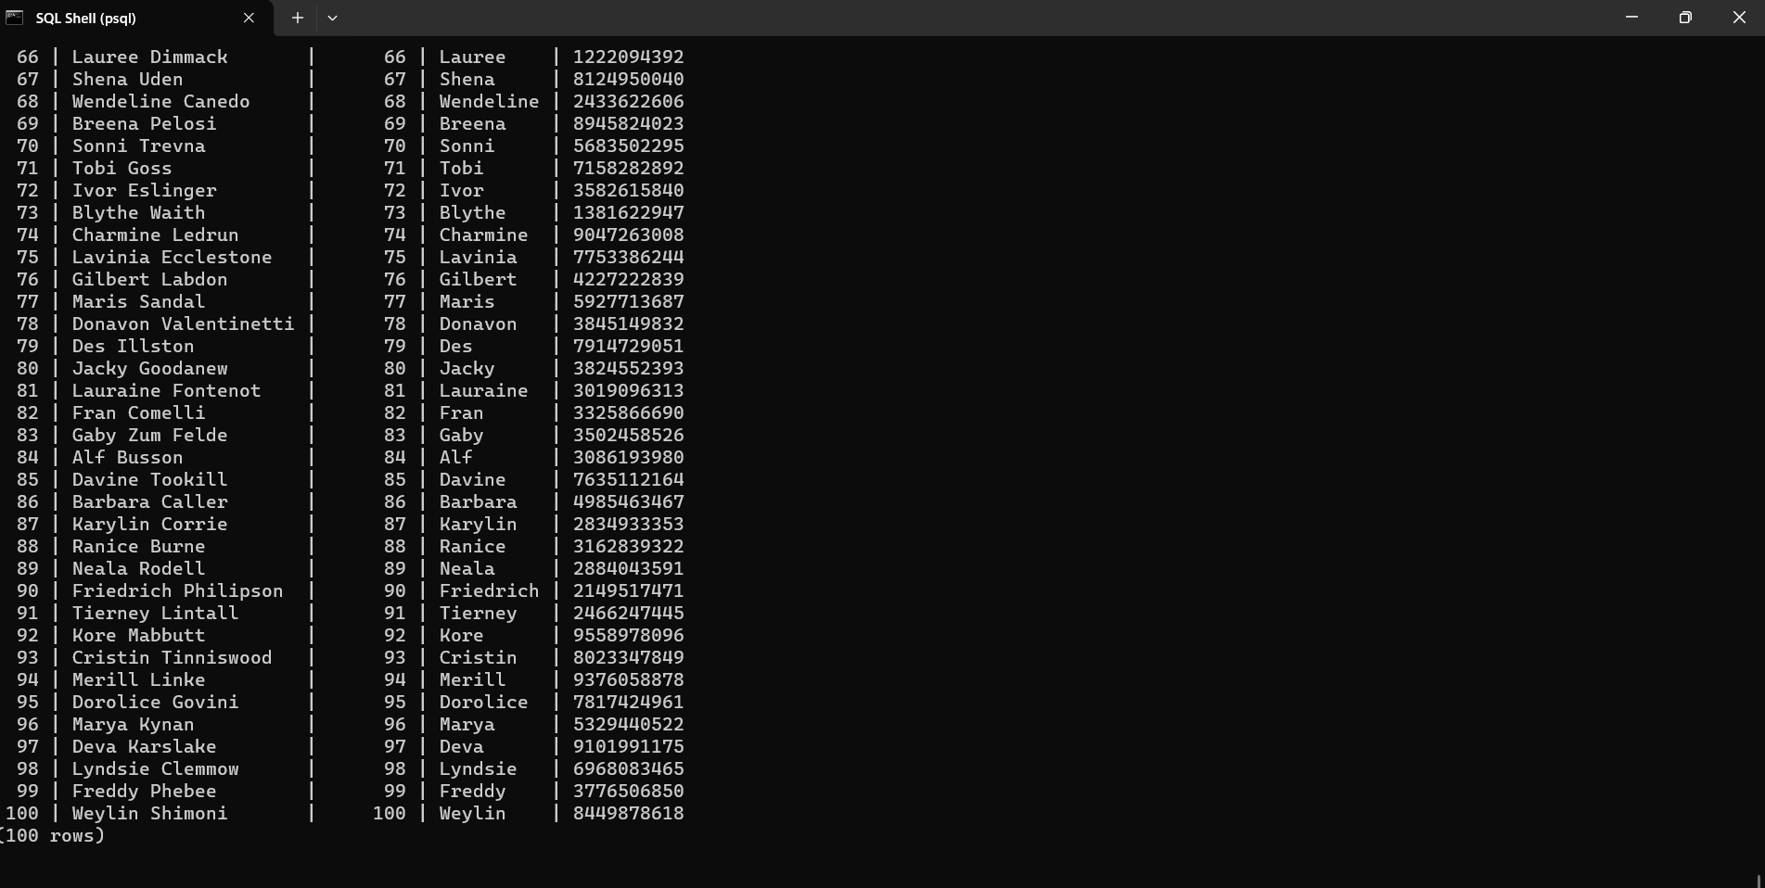

Update query

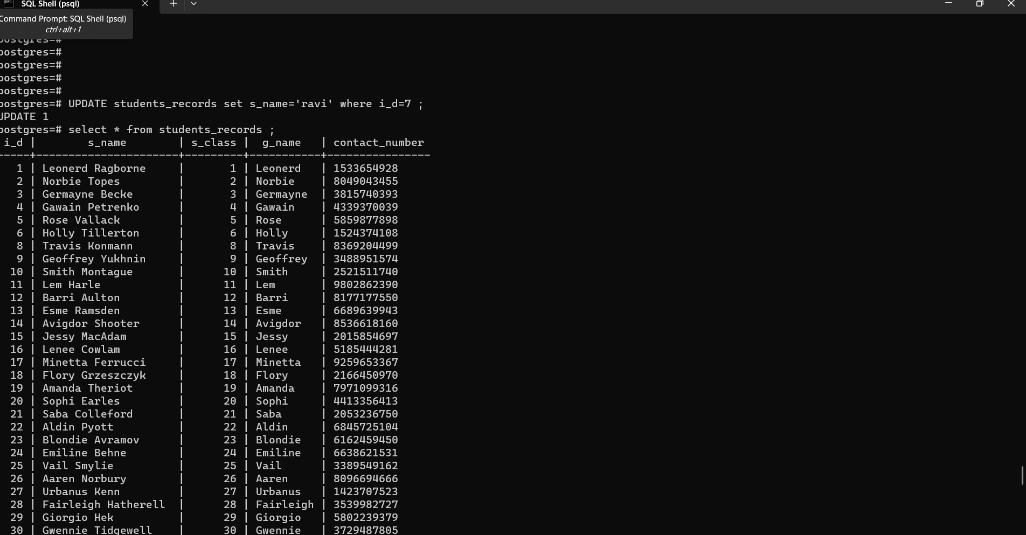

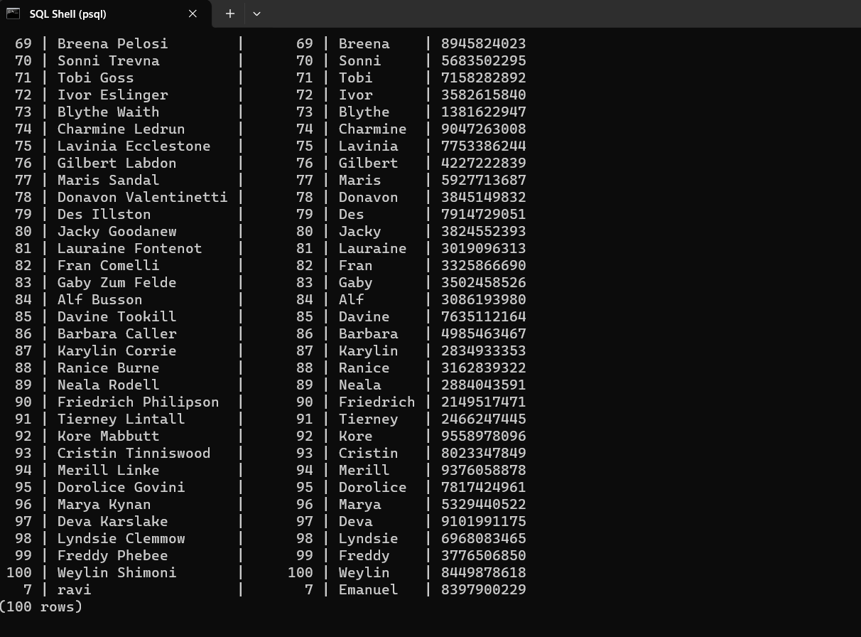

Similarly table for teachers class and students are crated